1.What is data?
Data is a collection of raw, unorganized facts, figures, observations, or symbols. By itself, it lacks context. Once processed, structured, and interpreted, it transforms into meaningful information that drives decision-making, analysis, and computing operations.
Examples of Data
- Student name
- Employee ID
- Marks scored
- Mobile numbers
- Product prices
Core Types of Data
Data is generally categorized based on its format and nature:
- Quantitative Data: Numerical information that can be counted or measured (e.g., 50 kilograms, 120 beats/min).
- Qualitative Data: Descriptive, non-numerical information representing characteristics, categories, or opinions (e.g., color, taste, or survey feedback).
- Structured Data: Highly organized information typically stored in relational databases and spreadsheets, formatted in clean rows and columns (e.g., SQL tables).
- Unstructured Data: Raw, unformatted information that doesn't follow a predefined model (e.g., video files, audio recordings, emails, or social media posts).
- Semi-Structured Data: Information that doesn't reside in traditional tables but includes tags or markers to enforce a loose hierarchy (e.g., JSON, XML, or HTML files).

2. What is a Database?

A database is an organized, digital collection of structured information or data stored in a computer system. It allows users to efficiently store, retrieve, modify, and manage information using a software application called a Database Management System (DBMS).

Example

A college database may contain:
- Student details
- Faculty details
- Attendance records
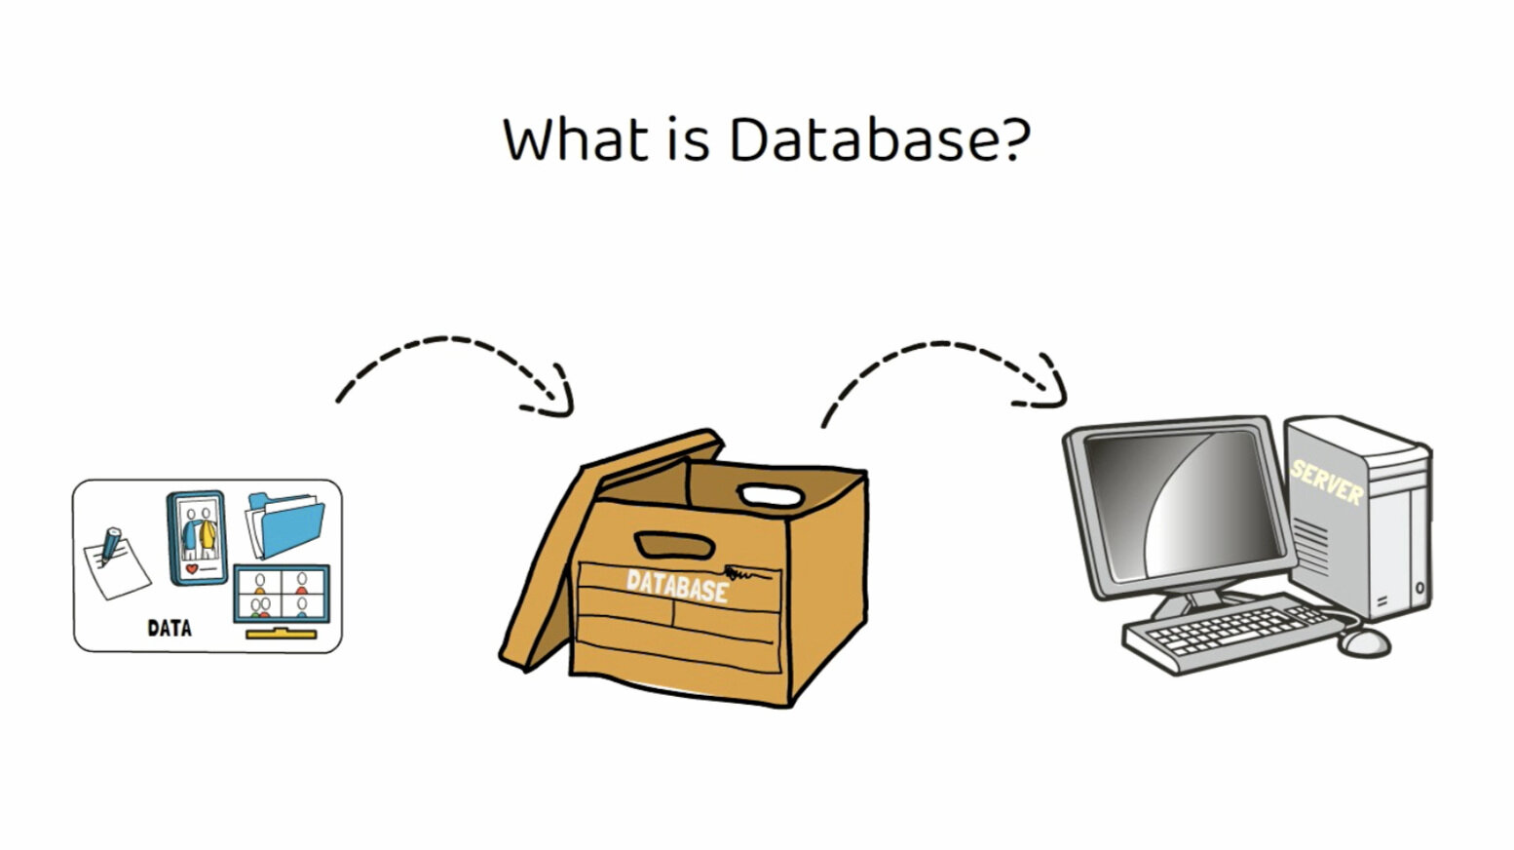
Types of Databases
- Relational (SQL): Organize data into structured tables with rows and columns. They use Structured Query Language (SQL) and are ideal for financial records and systems requiring high consistency.
- Non-Relational (NoSQL): Store data in flexible, unstructured formats like key-value pairs, documents, or graphs. Ideal for rapid scaling and unstructured data like social media posts.
- Cloud Databases: Hosted on virtual platforms (like AWS or Azure), making them highly scalable and accessible from anywhere.
- Vector Databases: Designed to store and query high-dimensional vector embeddings, a critical technology used in AI and machine learning.

3. Why Do Organizations Store Data in Databases?
Organizations store data in databases to ensure secure, centralized, and highly structured management of massive information volumes. Unlike basic file systems, databases allow teams to search, update, and analyze data efficiently, which reduces human error and drives faster, data-backed decision-making.
Example
Banks use databases to store:
- Customer details
- Account balances
- Transaction history
- Loan information
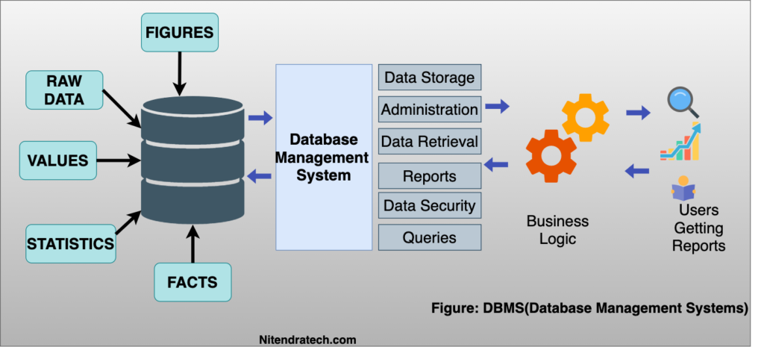
Reasons for Using Databases
1. Easy Data Management
Databases help store and organize huge amounts of information systematically.
2. Fast Data Retrieval
Information can be searched and accessed quickly using queries.
3. Data Security
Only authorized users can access or modify the data.
4. Reduced Data Redundancy
Duplicate data is minimized, saving storage space.
5. Data Consistency
Accurate and consistent data is maintained across the organization.
6. Backup and Recovery
Databases provide backup and recovery mechanisms to prevent data loss.
7. Better Decision Making
Organizations analyze database information to make business decisions.

4. Examples of Relational Databases
Relational databases (RDBMS) store data in structured tables of rows and columns, linked together using shared identifiers (keys). They use Structured Query Language (SQL) for managing data. Popular examples include MySQL, PostgreSQL, Oracle Database, Microsoft SQL Server, and SQLite.
Popular Relational Databases
Database Name | Description
MySQL | Open-source relational database widely used in web applications
Oracle Database | Enterprise-level database developed by Oracle Corporation
Microsoft SQL Server | Relational database developed by Microsoft
PostgreSQL | Advanced open-source relational database
SQLite | Lightweight relational database used in mobile and desktop applications
MariaDB | Community-developed relational database based on MySQL
5. What is a Data Warehouse?
A Data Warehouse is a centralized repository used to store large amounts of historical data collected from different sources for analysis and reporting purposes. It is mainly used for business intelligence and decision-making.
How it Works (The ETL Process)
Data doesn't just flow into a warehouse automatically. It relies on a pipeline called ETL (Extract, Transform, Load):
- Extract: Pulls raw data from various sources like CRM tools, financial software, point-of-sale systems, and operational databases.
- Transform: Cleans, formats, and standardizes the data so it remains consistent and structured.
- Load: Moves the cleaned data into the central data warehouse for querying.

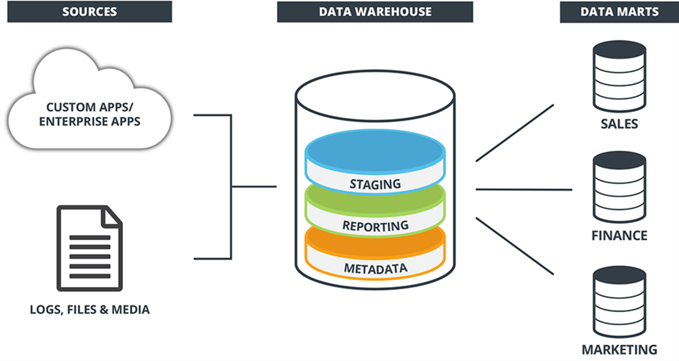

Components of a Data Warehouse
- Data Sources
- ETL Process (Extract, Transform, Load)
- Data Storage
- Reporting and Analysis Tools
Advantages of a Data Warehouse
- Improves business analysis
- Helps in decision-making
- Provides historical insights
- Generates reports efficiently

